Practical 5: Configure IPv6 ACLs

Topology:

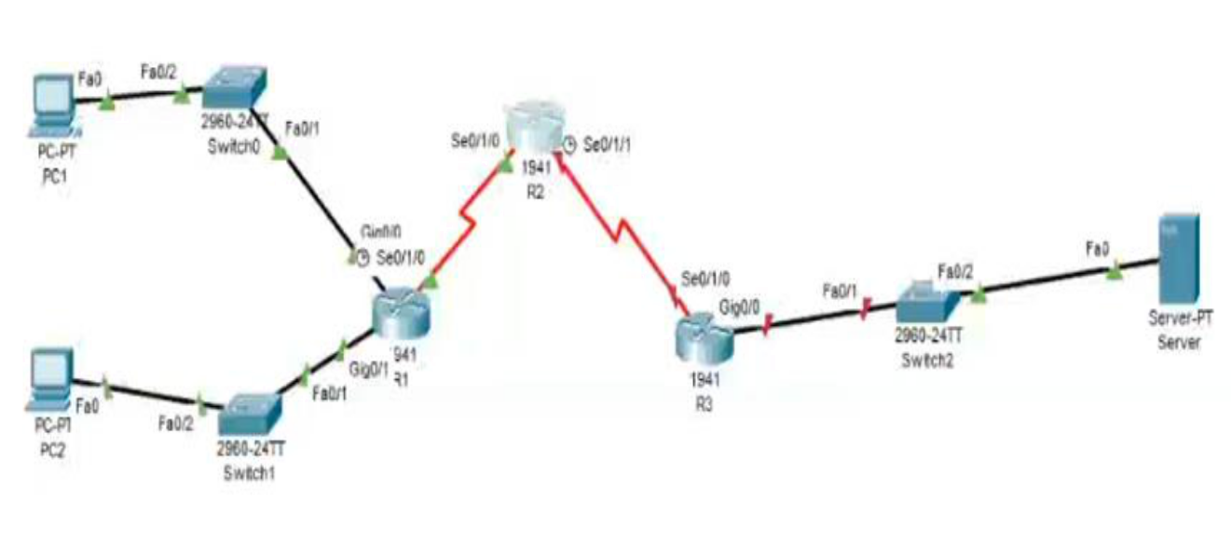

Addressing Table:

Device | Interface | IPv6 Address/Prefix | Default Gateway
PC1 | NIC | 2001:DB8:1:10::10/64 | FE80::1
PC2 | NIC | 2001:DB8:1:11:11/64 | FE80::1
 | gig0/0 | 2001:DB8:1:10::1/64 | FE80::1
R1
R1 | se0/1/0 | 2001:DB8:1:1::1/64 | FE80::1
 | gig0/1 | 2001:DB8:1:11::1/64 | FE80::1
R2 | se0/1/0 | 2001:DB8:1:1::2/64 | FE80::2
 | se0/1/1 | 2001:DB8:1:2::2/64 | FE80::2
R3 | gig0/0 | 2001:DB8:1:30::1/64 | FE80::3
 | se0/1/0 | 2001:DB8:1:2::1/64 | FE80::3
Server | NIC | 2001:DB8:1:30::30/64 | FE80::3

Objective:

- Configure, Apply, and Verify an IPv6 ACL

- Configure, Apply, and Verify a Second IPv6 ACL

Configure Router:

Step 1: Configure secret on router

Execute command on all routers

R(config)# enable secret enpa55

Step 2: Assign static ipv6 address

R1(config)# int gig0/0

R1(config-if)# ipv6 address 2001:DB8:1:10::1/64

R1(config-if)# ipv6 address FE80::1 link-local

R1(config-if)# no shut

R1(config)# int gig0/1

R1(config-if)# ipv6 address 2001:DB8:1:11::1/64

R1(config-if)# ipv6 address FE80::1 link-local

R1(config-if)# no shut

R1(config)# int se0/1/0

R1(config-if)# ipv6 address 2001:DB8:1:1::1/64

R1(config-if)# ipv6 address FE80::1 link-local

R1(config-if)# no shut

R2(config)# int se0/1/0

R2(config-if)# ipv6 address 2001:DB8:1:1::2/64

R2(config-if)# ipv6 address FE80::2 link-local

R2(config-if)# no shut

R2(config)# int se0/1/1

R2(config-if)# ipv6 address 2001:DB8:1:2::2/64

R2(config-if)# ipv6 address FE80::2 link-local

R2(config-if)# no shut

R3(config)# int gig0/0

R3(config-if)# ipv6 address 2001:DB8:1:30::1/64

R3(config-if)# ipv6 address FE80::3 link-local

R3(config-if)# no shut

R3(config)# int se0/1/0

R3(config-if)# ipv6 address 2001:DB8:1:2::1/64

R3(config-if)# ipv6 address FE80::3 link-local

R3(config-if)# no shut

Step 3: Enable IPv6 routing

R1(config)# ipv6 unicast-routing

R1(config)#ipv6 route 2001:DB8:1:2::0/64 2001:DB8:1:1::2 R1(config)# ipv6 route 2001:DB8:1:30::0/64 2001:DB8:1:1::2

R2(config)# ipv6 unicast-routing

R2(config)# ipv6 route 2001:DB8:1:10::0/64 2001:DB8:1:1::1

R2(config)# ipv6 route 2001:DB8:1:11::0/64 2001:DB8:1:1::1

R2(config)# ipv6 route 2001:DB8:1:30::0/64 2001:DB8:1:2::1

R3(config)# ipv6 unicast-routing

R3(config)# ipv6 route 2001:DB8:1:10::0/64 2001:DB8:1:2::2 R3(config)# ipv6 route 2001:DB8:1:11::0/64 2001:DB8:1:2::2
R3(config)# ipv6 route 2001:DB8:1:1::0/64 2001:DB8:1:2::2

Step 4: Verify connectivity

PC1> ping 2001:DB8:1:30::30

(Successful)

PC2> ping 2001:DB8:1:30::30

(Successful)

Part 2: Configure, Apply, and Verify an IPv6 ACL

Step 1: Configure an ACL that will block HTTP and HTTPS access.

R1(config)# ipv6 access-list BLOCK_HTTP
R1(config-ipv6-acl)# deny tcp any host 2001:DB8:1:30::30 eq www R1(config-ipv6-acl)# deny tcp any host 2001:DB8:1:30::30 eq 443 R1(config-ipv6-acl)# permit ipv6 any any
R1(config-ipv6-acl)# exit

Step 2: Apply the ACL to the correct interface.

R1(config)# int gig0/1

R1(config-if)# ipv6 traffic-filter BLOCK_HTTP in

Step 3: Verify the ACL implementation

Open a web browser to the PC1 to display the web page. Desktop->Web Browser->http://2001:DB8:1:30::30 (Successful)

Desktop->Web Browser->https://2001:DB8:1:30::30 (Successful)

Open a web browser to the PC2 to display the web page. Desktop->Web Browser->http://2001:DB8:1:30::30 (Unsuccessful) – Request Timeout

Desktop->Web Browser->https://2001:DB8:1:30::30 (Unsuccessful) – Request Timeout
PC2> ping 2001:DB8:1:30::30

(Successful)

Part 3: Configure, Apply, and Verify a Second IPv6 ACL

Step 1: Create an access list to block ICMP. R3(config)# ipv6 access-list BLOCK_ICMP R3(config-ipv6-acl)# deny icmp any any
R3(config-ipv6-acl)# permit ipv6 any any
R3(config-ipv6-acl)# exit

Step 2: Apply the ACL to the correct interface.

R3(config)# int gig0/0

R3(config-if)# ipv6 traffic-filter BLOCK_ICMP out

Step 3: Verify that the proper access list functions.

PC2> ping 2001:DB8:1:30::30 (Unsuccessful) - Destination host unreachable
PC1> ping 2001:DB8:1:30::30 (Unsuccessful) - Destination host unreachable

Open a web browser to the PC1 to display the web page.

Desktop->Web Browser->http://2001:DB8:1:30::30

(Successful)

Desktop->Web Browser->https://2001:DB8:1:30::30

(Successful)

